**Programming Assignment – 1:**

**Q1. (a)**

**Results:**

1. **Sigma = 1,**

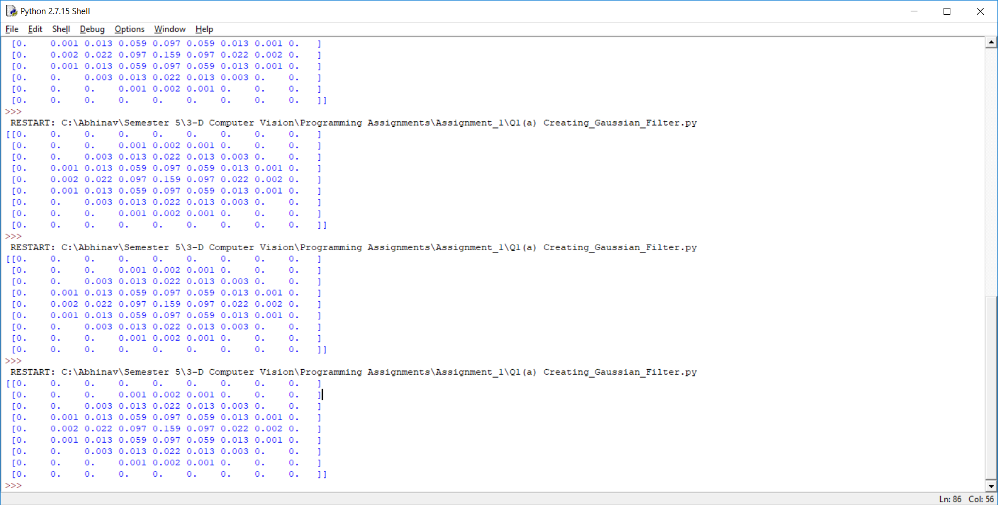

1. **Sigma = 3,**

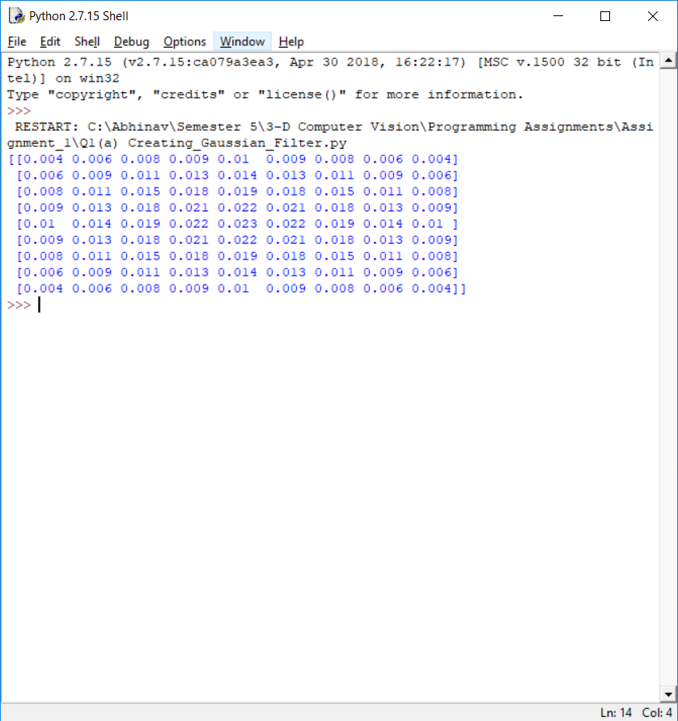

1. **Sigma = 20,**

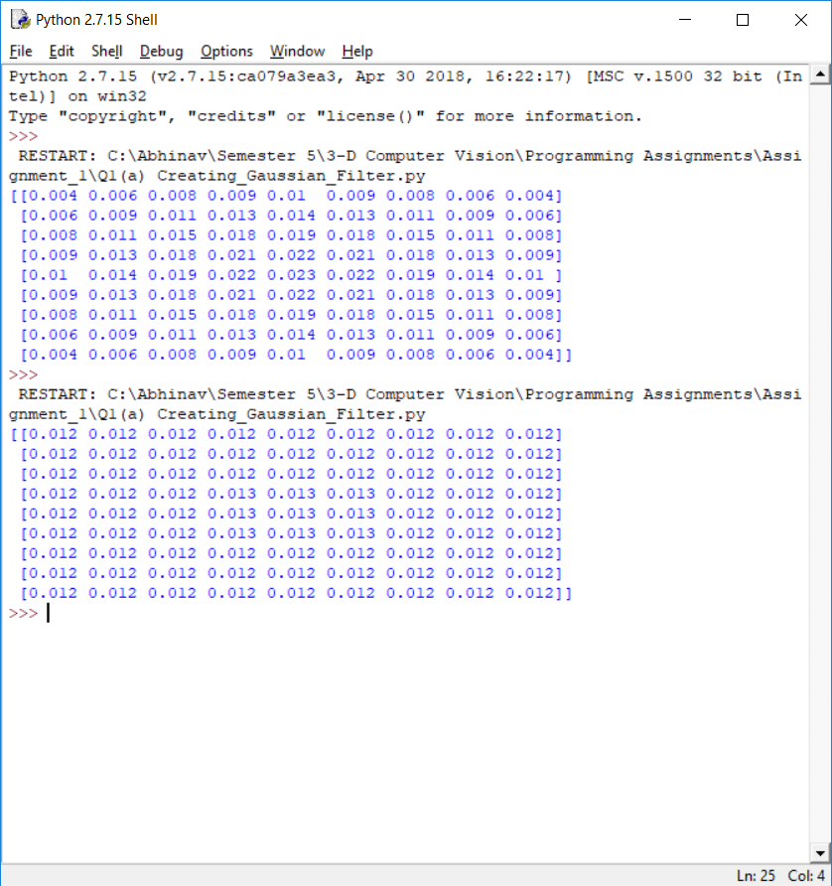

**Observations:**

1. It is observed in all three cases, that the output is maximum at the central pixel and reduces as we move towards the edge of the filter.
2. For a smaller value of sigma, it is observed that the output is highly concentrated at the central portion, with the value close to the edge of the filter becoming zero.
3. As we increase the variance of the filter the values spread out more evenly ultimately tending to a mean filter as sigma becomes very large.

**Q1(b)**

1. **Original Image:**

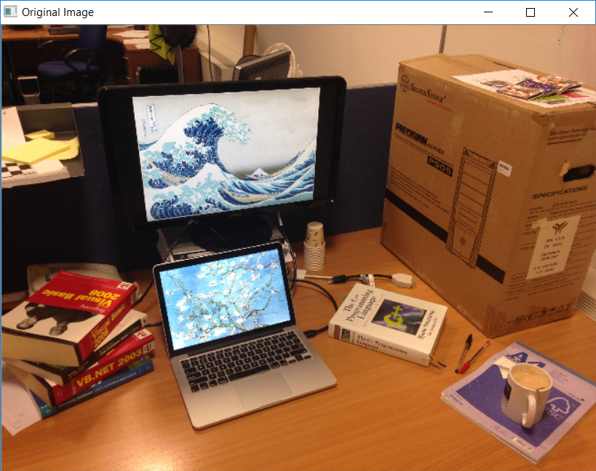

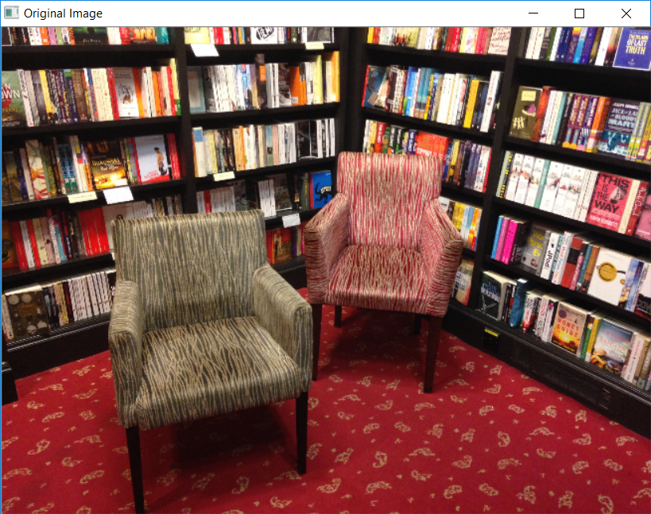

1. **Sigma = 1**

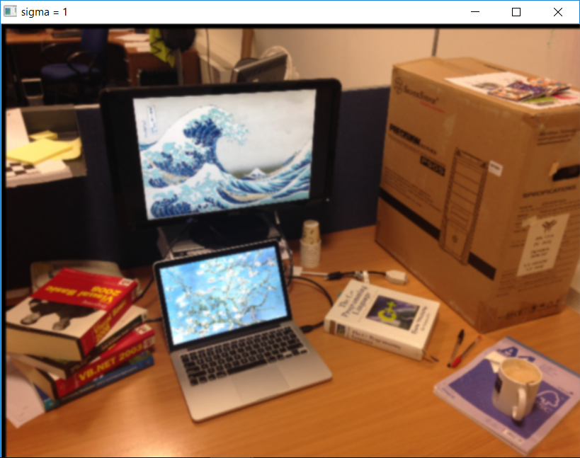

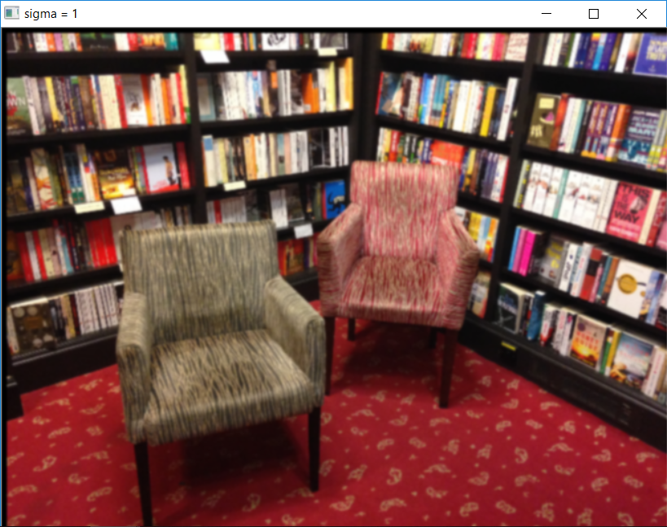

1. **Sigma = 3**

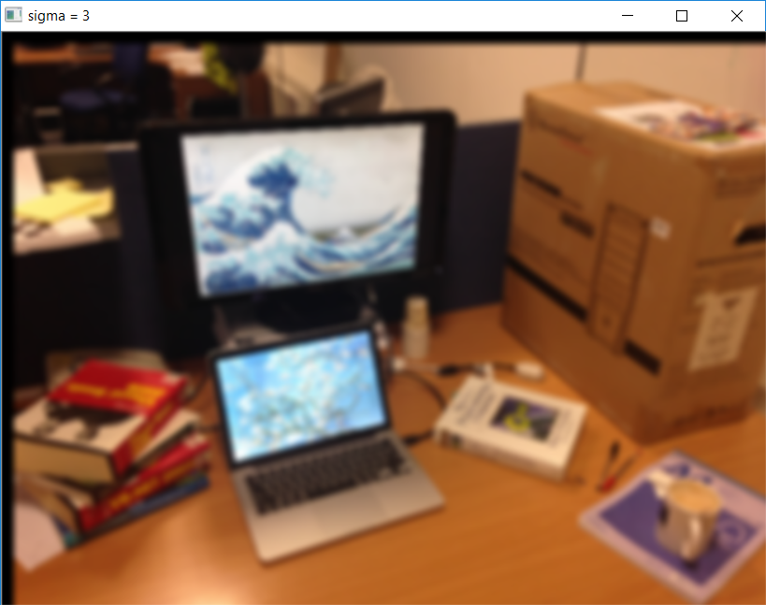

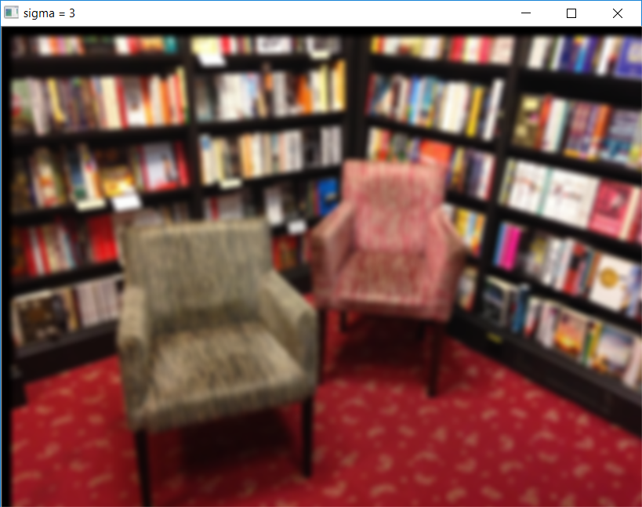

1. **Sigma = 20**

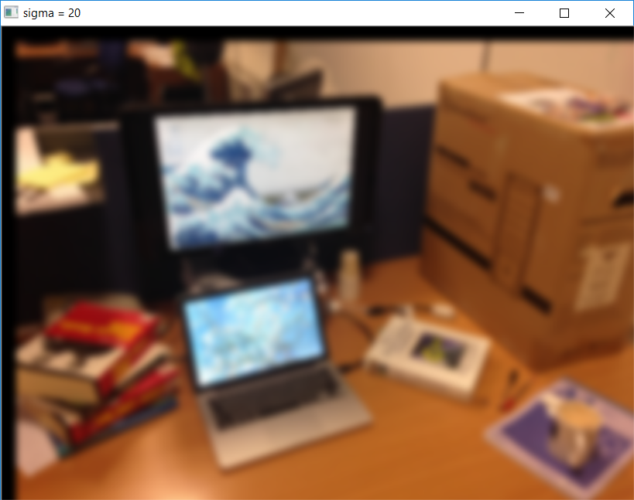

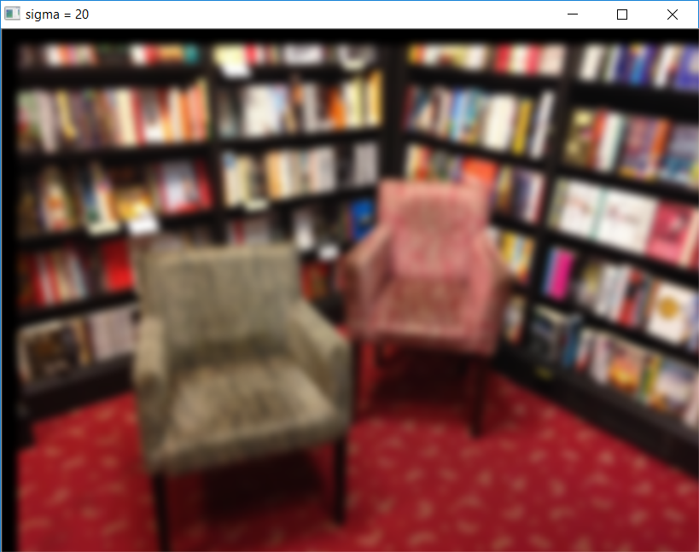

**Observations:**

1. It is observed that as sigma is increased, the blurring of the image increases. As the variance increases, the gaussian becomes flatter and flatter in the limiting case it tends to a mean filter.
2. A smaller value of variance gives more weight to the central pixel resulting in less blurring. This is clearly evident in the results.

**Q2(a)**

The Designed DOG filter is as shown below,

The standard deviations of the Gaussian kernels are stdv1 = 1, stdv2 = 1.5 respectively.

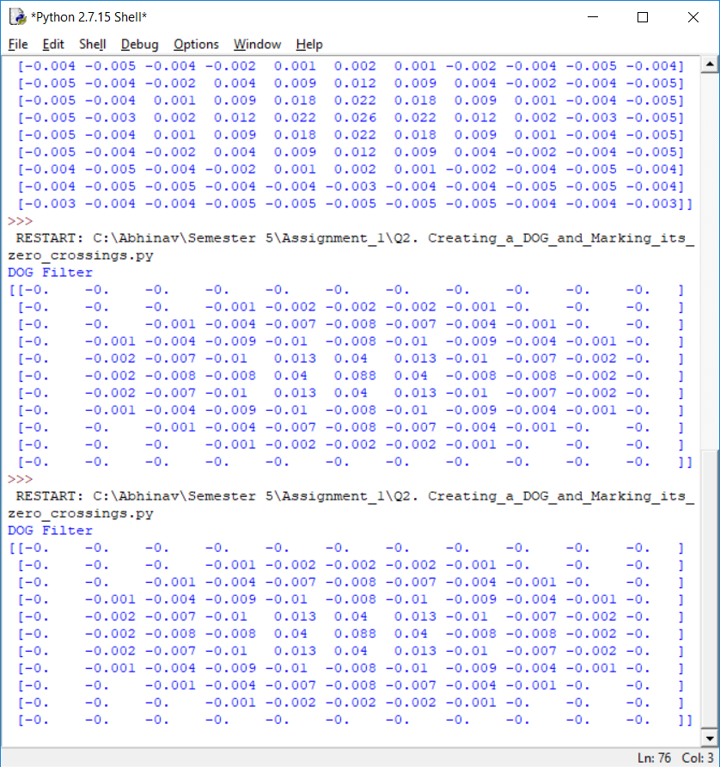

**Observations:**

1. The DOG is obtained by taking the difference of two normalized gaussians, thus the sum of all values of the DOG would be zero.
2. By definition the DOG is a high pass filter and thus obtained by taking the difference of two gaussians on the original image.

**Q2(b)**

The Obtained DOG output on the input image is as shown below,

**Input Image:**

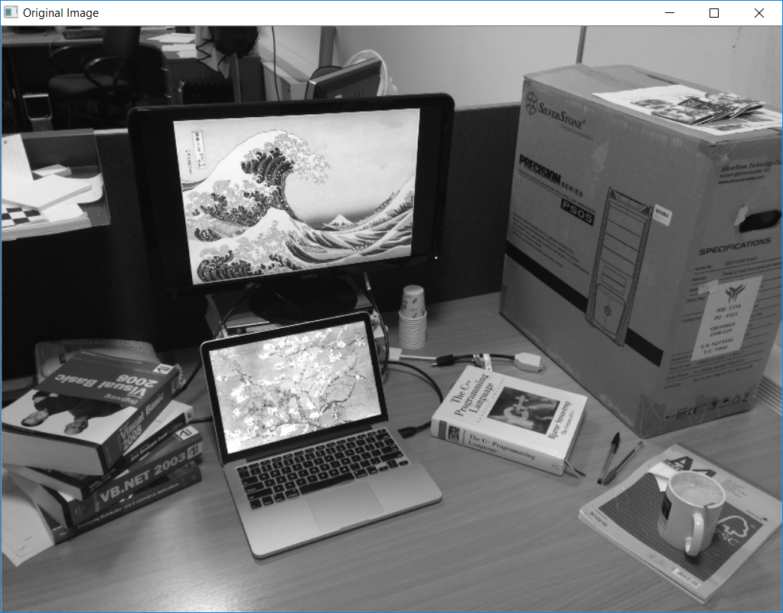

**Obtained DOG Output:**

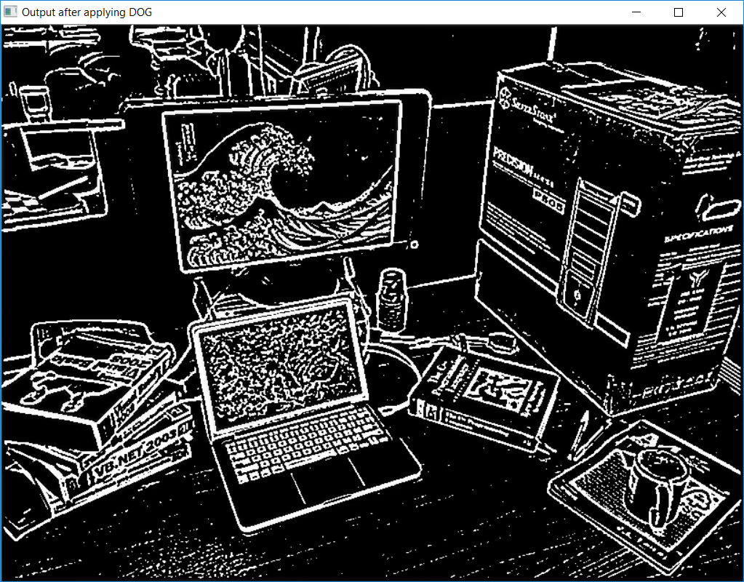

**Observations:**

1. The observed, DOG output highlights the edges in the original image and thus acts as a high pass filter.
2. **Detected Zero Crossings**

**Input Image:**



**Detected Zero Crossings.**

Threshold value = 0.5

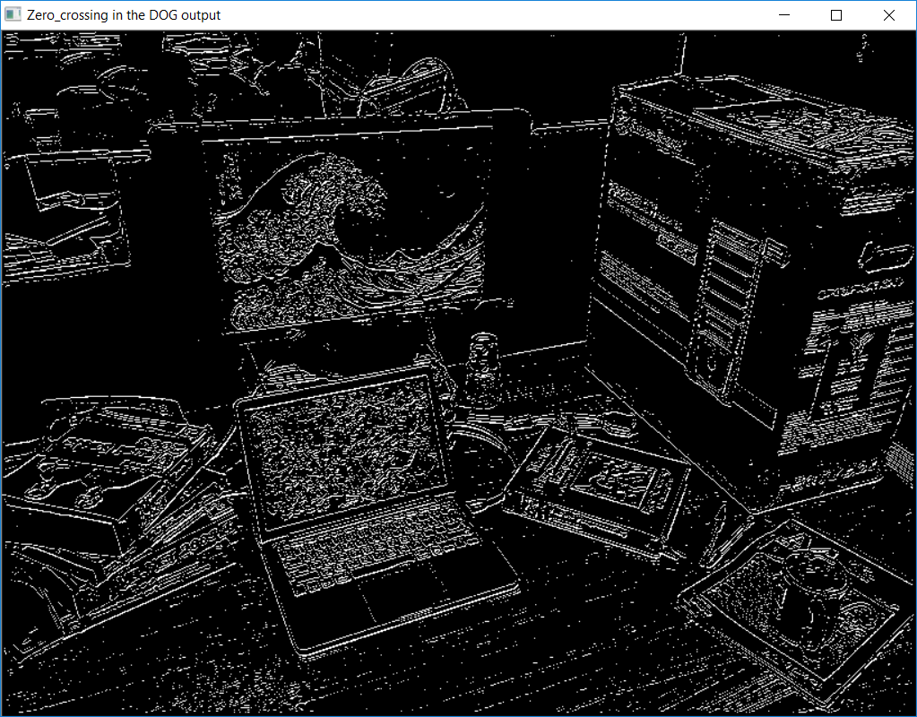

**Observations:**

1. As expected the DOG highlights the edges (high frequency components) in the original image.
2. The output obtained from the Zero crossings of the DOG operator has many components that are not edges. This is due to the presence of noise in the image. The spurious edges have to be eliminated by further processing. This procedure is not sufficient to isolate edges in the image.
3. Certain number of zero crossings have been neglected by the process of thresholding.